Fighting for Pride – The Italian Path to LGBTQIA+ Resistance
Documentation Center “Flavia Madaschi” and Cassero LGBTQIA+ Center
Design Brief Summary
Authors
Nicoletta Ascione, Silvia Lusenti, Alice Sgarlata
Affiliations / Course / Institution
Digital Heritage and Multimedia Project, Digital Humanities and Digital Knowledge Project 2025/206
Author emails
nicoletta.ascione@studio.unibo.it, alice.sgarlata@studio.unibo.it, silvia.lusenti@studio.unibo.it

Abstract

Fighting for Pride is a hybrid phygital exhibition taking place at Cassero LGBTQIA+ Center, developed in collaboration with the Documentation Centre “Flavia Madaschi”, the largest LGBTQIA+ community archives in Europe. The main objective of the exhibition is to inform the visitor about the most important steps of Italian LGBTQAI+ history that led to the establishment of Pride in our country.
The project addresses a dual problem: the general public’s limited awareness of the Italian LGBTQIA+ movement’s history, and the archive’s lack of a dedicated permanent exhibition space. The proposed solution is an immersive walk-through installation structured as a physical march, recreating the concept of a Pride march from the outside courtyard to the indoor venue, spanning seven chronological zones from the Stonewall Riots in 1969 to the most recent “Rivolta Pride”.
Visitors physically walk through fifty years of history, surrounded by archival materials (posters, photographs, audio and video testimonies), guided also by a web app providing in-depth multimedia content. The exhibition ends in the venue’s ballroom, where visitors can live an immersive experience with a 360° VR recording of the Rome Pride 2016.
The project aims to make this history emotionally accessible and permanently documented in digital form. Visitors are invited to leave their own memory for the archive’s collection, making the exhibition a living contribution to the heritage it represents.

Keywords (5–7)
exhibition; museum experience; Pride; LGBTQIA+ history; civil rights; archive documents

1. Introduction and Design Problem

1.1 Context of the project
The project takes place at Cassero LGBTQIA+ Center, located in via Don Giovanni Minzoni 18, Bologna. The project is developed through documents collected by the Documentation Center “Flavia Madaschi”, the biggest community archive in Italy and Europe specialized in the preservation of LGBTQIA+ history. Given that it is not a museum per se, it does not have a dedicated place for galleries or exhibitions. However, a court and a large hall underneath the archive are available: we imagined our exhibition to take place there.
1.2 Main pain points / problems the project aims to solve
The exhibition project responds to four interconnected problems identified through on-site visits, discussions with Cassero staff, and analysis of the archive’s current public communication.
- First, the Documentation Center is largely unknown even to regular visitors of Cassero: the archive holds over 21,000 books, 10,000 audiovisuals and 5,000 posters, yet most of this heritage is invisible to the general public.
- Second, the archive has no dedicated gallery or exhibition space, requiring any installation to adapt to multi-purpose areas (a courtyard and an event hall in this case).
- Third, a significant portion of the archive’s most important materials are audiovisual (recordings, videos, testimonies), which a purely physical exhibition cannot convey adequately.
- Fourth, the sheer volume of digital content in the archive risks remaining inaccessible without structured digital guidance for visitors and researchers.
These four problems are addressed as design constraints: they shape the choice of a phygital format, the integration of a companion WebApp, the VR finale, and the Twine-based interactive narrative as a permanent digital record of the visit.

Pain point / problem | Who is affected? | Why does it matter for the design?
Cassero regulars aren’t aware of the archive’s existence, missing crucial information on Italian Pride. | The audience | The design must provide sufficient historical information in a captivating way
The archive does not have a dedicated space for exhibitions. It does have a court outside, and a hall dedicated to events. | The audience | The design has to adapt to the available space, which is partially outdoors.
A large portion of the material preserved by Cassero is multimedial (registration, videos…). | The archive | A large portion of the exhibition has to be dedicated to multimedial content.
The archive is so large that it may be hard to browse through the digital content without guidance. | The audience | The exhibition must be digitized to be a permanent guide for researchers and people interested in Cassero’s work,

2. Related Work, Benchmarks and Existing Solutions

2.1 Existing references, comparable projects and technologies
The design drew on a range of references spanning political history exhibitions, digital heritage experiences, and community archive projects:
- Hope to Nope: Graphics and Politics 2008-18 (Graphic Design and, London, 2019) presents political turbulence through tangible graphic artefacts (posters, stickers, memes) curated chronologically. Its strength lies in visual culture as a primary historical source, an approach directly relevant to the Archive’s poster collection. Its limitation for our project is the absence of any digital or multimedia layer, and the fact that the exhibition is no longer accessible. Some of the posters digitalized by the Archive are too old or fragile to be shown to the public.
- Copy Machine Manifestos: Artists Who Make Zines (Brooklyn Museum, 2023-24) uses printed ephemera to document marginalised communities’ self-representation. It provides a strong model for displaying grassroots political materials with curatorial depth. However, the Brooklyn Museum’s scale and budget are incomparable to the constraints of a community archive venue.
- The LGBTQ+ VR Museum (DiVRse Technologies, 2022) shows a virtual reality museum dedicated to preserving the history, culture, and experiences of LGBTQ+ community members around the world.Through immersive VR technology, visitors can explore interactive exhibitions featuring digital artifacts, artworks, personal stories, and historical events. The museum aims to make LGBTQ+ heritage accessible to everyone.

Reference / project / technology | What it does well | Gap for your project
https://www.graphicdesignand.com/shows/hope-to-nope | It shows political history and turbulence through tangible traces, focusing on a particular (in their case, aesthetic) key. | Multimedia elements are missing, the exhibition was not rendered digitally so it is no longer accessible.
https://www.brooklynmuseum.org/exhibitions/copy_machine_manifestos_artists_who_make_zines | It displays marginalized people’s influence in history through an art medium. | Although the exhibition traces the history of zines up to the present day, it offers little insight into the evolution of DIY publishing through webzines, blogs, and digital platforms
https://lgbtqvrmuseum.com/ | Encourages empathy, understanding, and engagement with LGBTQAI+ history and community. | Great emphasis on individual narratives than on the broader historical and activist contexts.
https://cassero.it/centro-documentazione/ | It displays a rich archive of LGBTQAI+ history in a digital format. | The center prioritizes documentation and preservation, making its rich collection less accessible and engaging.

2.2 Gap statement: what existing solutions do not solve
Similar existing projects either haven’t left any digital sources of the exhibition, or they are no longer available. The project goal is to provide a stable digital guide through Cassero’s material, even if it will eventually be just digital.
Moreover, similar solutions lack the digital or physical counterpart; it is difficult to find an existing solution combining both layers. Lastly, similar solutions focus more on individual narratives rather than the bigger societal narrative that the project is trying to convey in displaying 40+ years of LGBTQIA+ activism

3. Method and Design Process

3.1 Design method used
- Briefing phase: during this preliminary phase we concluded that the aim of the exhibition would be to mimic a protest, marching through different key points in Pride history through posters, photos, videos and other multimedial content. The visit is aided by a WebApp that will store the content of the exhibition as well as additional content for the interested visitors.
- On-site visit and research phase: this phase consisted of an in-person visit to the archive and a discussion with the staff about the main objectives of the exhibition. The exact placement of the exhibition was decided, along with its path. The research involved gathering information through the many photographic books and memoirs available in the archive, along with browsing on their catalogue to select the posters, photos and art to be displayed during the exhibition. The discussion with the staff and their experience also allowed for the development of personas, based on the usual visitors they encounter and the people that frequent the archive
- Ideation: during this phase design specifics were established using Codesign. Then, the exhibition itself was established; the posters, photos and materials to be displayed were selected among the resources gathered in step 2, and consequently the related captions were written. A prototype of the exhibition was developed in Blender in order to visualize the physical installation and the position of all the elements. The WebApp connected to the exhibition, meant to provide further insight and extra material during and after the visit, was built in Figma.
- User journey: this phase involved the simulation of a user visiting the exhibition with Twine.

Design activity | Output produced | Where it appears in this paper
Concept design | A phygital exhibition centered around Italian LGBTQIA+ history, in collaboration with Il Cassero and the Flavia Madaschi Center. Selected items from the Center are displayed and access to multimedia resources is provided. The exhibition is structured like a Pride march and ends in the hall where a VR experience is available. | Section 4
Experience loop | An exhibition structured in physical and digital layers that lead to the enrichment of personal in-depth knowledge about Italian Pride development. | Section 5
Experience mechanics | A hybrid, personalized experience that enriches the physical collection and its materials. | Section 5
User flowchart | A flowchart mapping the visitor’s path while engaging with the different physical and digital entities of the exhibition. Step-by-step decisions of the visitor who can choose the best suiting way to engage with the exhibition. | Section 6
Swimlane flowchart | A swimlane flowchart explaining the different interactions between the visitor, the physical elements and the digital ones (WebApp, VR). | Section 6
User journey map | A Twine detailing the user journey. | Section 7

3.2 Data/materials used: cards, museum sources, student observations, references
- Primary sources: the Documentation Centre “Flavia Madaschi” catalogue (centrodocumentazionecassero.it/cerca ), from which posters, photographs, periodicals and audiovisual materials were selected or sent to us by direct contact. Cassero’digital exhibition /centrodocumentazionecassero.it/storia as an example of a digital exhibition.
- Secondary sources: Wikipink (www.wikipink.org) for the complete list of Italian Pride events; journalistic archives (La Repubblica, Wired Italia) for contemporaneous accounts of key events; Youtube and Wayback Machine by Internet Archive for audio-visual testimonies (Vladimir Luxuria, 2009; Flavia Madaschi, 2012-2014; Lady Gaga Europride speech, 2011; Rome Pride 360° VR video, 2016).
- On-site research: an in-person visit to the Cassero archive, during which the available physical spaces were surveyed and the exhibition path was decided in collaboration with the archive staff. The visit also allowed direct access to photographic books and unpublished memoirs held by the archive.

4. Design Brief

Design brief element |  |  |  | Student answer
Title |  |  |  | Fighting for Pride – The Italian Path to LGBTQIA+ Resistance
Type of application / game |  |  |  | Hybrid exhibition
Primary audience |  |  |  | LGBTQAI+ community members and allies that already know about the international history and want to learn more about Italian Pride (18-25+)
Secondary audience |  |  |  | Uninformed adults getting to know for the first time about civil rights history (26+)
Primary persona, short description |  |  |  | Nora, a 23-year-old international Humanities student in search of interesting topics to read about. She is interested and knowledgeable in international Pride history but lacks a general background on Italian queer history.
Secondary persona, short description |  |  |  | Giovanna, a 60-year-old Italian tourist exploring Bologna and encountering our exhibition by chance. She is not particularly interested nor informed in the topics, nor very comfortable with technology.
Project focus / context |  |  |  | Court and hall of Cassero archive. Use of personal devices and provided headphones to access multimedial content through a web app. The same content will be present in the exhibition for people that don’t have a smartphone available. VR headsets will be present in the final stage of the exhibition - the hall - to watch a 360° video of a Pride march.
Star asset |  | Short description |  |  |  | Media / image placeholder
Lady Gaga’s speech |  | Lady Gaga’s speech at Rome’s EuroPride. Her performance is capable of sparking interest in people who would be otherwise uninterested in queer rights. (Fame) |  |  |  | 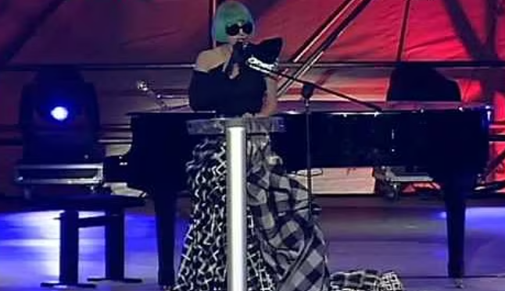
The archival collection of LGBTQAI+ material |  | The Flavia Madaschi Center is the biggest European community archive regarding queer history and civil rights. (Learning activity) |  |  |  | 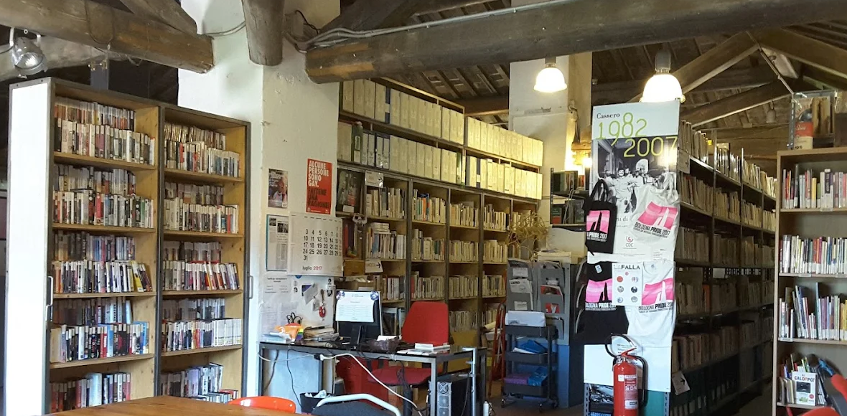
Institution / client |  | Institutional goals |  |  |  | Audience goals
Centro Documentazione Flavia Madaschi – Il Cassero |  | 1. Publicize and display their collection (Use assets in new ways)  2. Educate on their mission of preserving LGBTQIA+ history (Increase outreach) |  |  |  | 1.Learn about Italian LGBTQIA+ history in an engaging way (Extend knowledge)  2. Discover an often overlooked archive of books and multimedia relating to LGBTQIA+ culture, gender studies, and civil rights (Learn about heritage protection)
Audience | Motivations |  | Barriers |  | Capabilities |  | Devices
Young international students (18-25) | 1. Discover more about Italian Pride (Personal relevance)  2. Find an interesting exhibition on an often-overlooked topic (Stimulation) |  | 1. Language barrier, which could stop them from discovering books and articles about the topic  2. Not knowing where to get the information from, because the archive is underpublicized (Hidden) |  | 1. Use of digital tools (Websites, mixed reality)  2. Knowledge about general queer history  3. Willingness to learn more |  | 1. Smartphone  2. VReality  3. Headset
Adults, visitors and locals (26+) | 1. Getting to know more about the city and its people (Social interaction)  2. Discover cultural phenomena previously unknown to them (Curiosity) |  | 1. Might have accessibility problems  2. The digital aspect of the exhibition (QR codes, VR) might be overwhelming (Lack of access to technology) |  | 1. Empathy  2. Basic use of digital tools (Websites)  3. Desire to get engaged in new, interesting stories |  | 1. Smartphone  2.VReality  3. Headset

5. Design: Concept and Mechanics

5.1 Main idea of the project / user experience description
The visitor’s journey through Fighting for Pride allows a single, uninterrupted physical path (the “parade”) which doubles as the user flow. There are no branching rooms or separate stations: the flow is linear in space, non-linear in engagement (visitors choose how deeply to interact with each zone).
The three parallel layers of the experience (physical installation, Twine narrative, and WebApp) operate simultaneously. The visitor always has the option to stay at the physical level (walking, reading panels), engage digitally (scanning QR codes to open web app content), or go deeper (listening to audio testimonies, watching video archives, experiencing VR).
This layered structure ensures accessibility across different visitor profiles: a casual visitor can complete the walk in under 30 minutes reading only the physical panels; an engaged visitor can spend even more time exploring multimedia content for every zone.
5.2 Winning/completion condition and scoring system
The exhibition is not competitive, therefore there is no scoring system; however, the exhibition can be considered “completed” once the visitor has seen all the items on display, has watched/read all the extra material, has engaged in the VR experience and has left a written thought about the experience.
At the end of the Twine narrative, a recap of all the actions done by the visitor will be shown, with numbers of how many texts were read, videos watched, and areas skipped.

6. User Flow, Interaction and Hybrid System

6.1 General user flow description
The visitor enters the exhibition. They read the description in the first panels (which talk about the Stonewall riots) and decide to either go straight ahead or to scan the QR code, which will lead them to the WebApp, where extra material about the first panels is stored. They will engage with the digital resource and subsequently go ahead to the next panels.
This process is then repeated throughout the exhibition. At each panel, the visitor decides whether to engage with the additional digital material or to go straight ahead after reading the captions on display.
After the whole exhibition, the visitor enters the hall and chooses whether to walk away or to further engage with the digital side of the exhibition. If they decide so, they will step into the VR space, they will put on the headset and experience the VR Pride footage.
At the end, the visitor can leave a small message to the organizers of the exhibition and further engage with the WebApp and its content at home.

Figure 1. General user flow diagram / flowchart
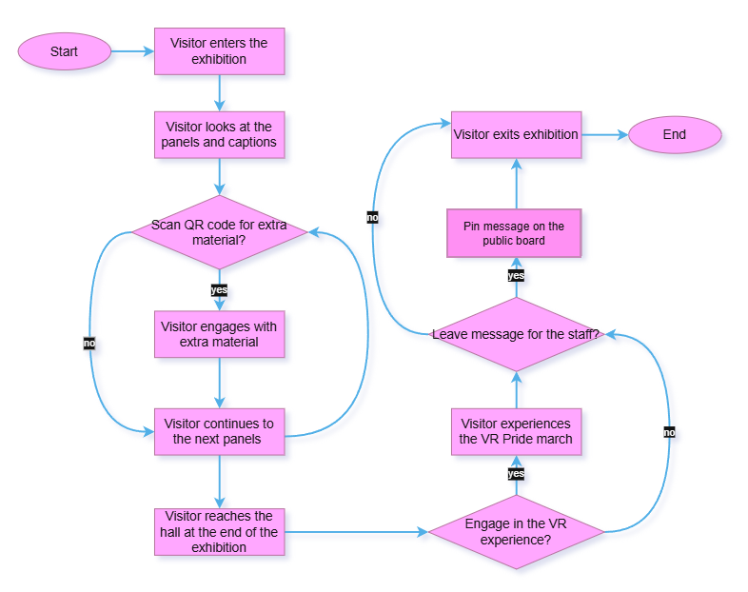

6.2 Swimlane flowchart description: actors, responsibilities, decisions and failure states
The swimlane flowchart shows the four actors of the exhibition: the visitor, the physical exhibition, the WebApp, and the VR experience.
- The visitor is responsible for how they will engage with the exhibition. In fact, they can decide to scan the QR codes or not, following only the physical exhibition; they can also decide what to specifically scan and look for on the WebApp; they can decide whether to participate in the VR experience or not.
- The physical exhibition provides the main stage in which the exhibition takes place. It’s composed of the panel which make up a path similar to one of a Pride march, and displays photos, posters, and informative captions about Italian Pride history. They follow a chronological timeline, starting with a small prologue about Stonewall Riots, going on with the 70s in Italy and ending with Rivolta Pride of the 2020s.
- The WebApp provides most of the digital material; by scanning the QR code on the panels (physical layer), the visitor can open it and thus access the extra material stored there, such as browsable, digitized magazines, and speeches.
- The VR experience provides a further digital layer, offering the possibility of participating in a Pride march using VR headsets.
All the decisions happen while visiting the exhibition: in fact, the visitor can decide to engage only with the physical layer, just by walking, observing, and reading the captions of the displayed material. Otherwise, they can access multimedia elements; this will give them the possibility to gain a more in-depth knowledge on the subject. Lastly, they can decide to also engage in the VR experience: that will give them the possibility to immerse themselves in what they just observed.

Figure 2. Swimlane flowchart
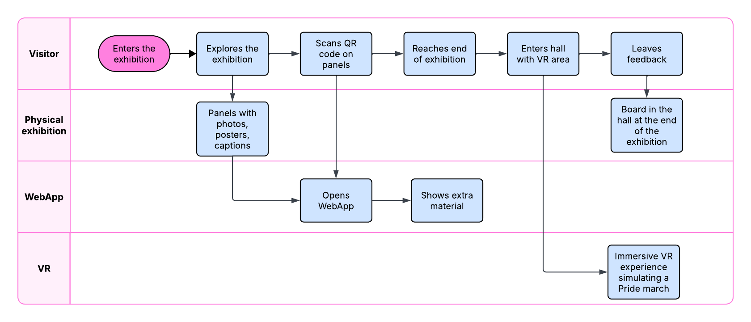

6.3 Interaction description and interaction categories
The interaction happens both on the physical level and on the digital one.
On the physical layer, the visitor interacts by observing the displayed posters and photos and by reading the captions.
Conversely, on the digital level, the visitor interacts by scanning the QR codes and browsing through the WebApp, watching the extra videos and flipping through digitized magazines. Another interaction that happens on the digital level is the VR experience, that starts when the visitor reaches the end of the exhibition, steps into the hall, and puts on the VR headset.
6.4 Hybrid and technological layers
The exhibition is structured on multiple layers and can be experienced accordingly; in fact, one could visit the exhibition only interacting with the physical layer, focusing mainly on the digital one, or combining both to have a full phygital experience.
The physical layer consists of the panels and the physical exhibition itself, with the selected items exposed following the timeline and the relative captions explaining the posters and photos. On top of that sits the digital layer, with the WebApp collecting extra material that can be accessed through the QR codes, integrating the physical exhibition.

Layer | Software / hardware / material | Function
Physical layer | Panels, printed items, captions | To guide the visitors and display the selected items; to carry on the main part of the exhibition.
Digital layer | WebApp, VR headset | To showcase multimedial content
Museum layer | Assisted guide / Virtual Rendering | Visitor receives orientation (panels + volunteers); opens web app via QR; Twine narrative starts.
Social layer | Hall, board | Visitors can gather and chat about their impressions. They can also write their thoughts and pin them on a board

7. User Experience as User Journey

7.1 User journey narrative
The visitor's journey begins before the exhibition itself: they learn about Fighting for Pride through Cassero's social channels, word of mouth, or simply by being at the venue for another event. No prior knowledge of Italian LGBTQIA+ history is assumed. At the entrance of the courtyard, a short orientation introduces the format: one continuous path, seven chronological zones, no rooms, and the visitor steps onto the route. The walk itself is the core of the experience.
The visitor moves at their own pace through fifty years of history, from Stonewall and the birth of FUORI! to the Rivolta Pride of 2021. At each zone, physical panels, reproductions of archival documents and photographs present the period; the Twine interactive narrative, mirrors the visitor's position along the route and offers small choices; stop at a testimony, examine a document up close, read the full text of the Cirinnà law on an interactive totem, or keep walking.
Each choice is recorded as a narrative variable. The emotional register is carried by the exhibited materials themselves: the typewritten flyers of the 1970s, the documents-only display of the 1980s (Giarre, the AIDS crisis), the return of colour with the first Prides of 1994–95, up to the portraits of the Bologna 2008 campaign and the hand-made banners of the Rivolta Pride.
The route ends in the Cassero ballroom, which holds the last two moments of the visit.
First, the VR experience: the visitor puts on a headset and watches a 360° recording of the Rome Pride: not a reconstruction, but an actual document, experienced from within the crowd. Then, the message wall: the visitor is invited to write their own message directly in the Twine interface, and to pin a physical card to the wall alongside those left by previous visitors.
The visit closes with a personalised ending generated by the Twine from the visitor's accumulated choices: how many testimonies they stopped for, whether they took their time in the heavier sections, and their own message, now displayed as part of the march. After the visit, the companion web app remains accessible, allowing the visitor to revisit and deepen every zone's content.
Figure 3. User Journey Map / UX diagram
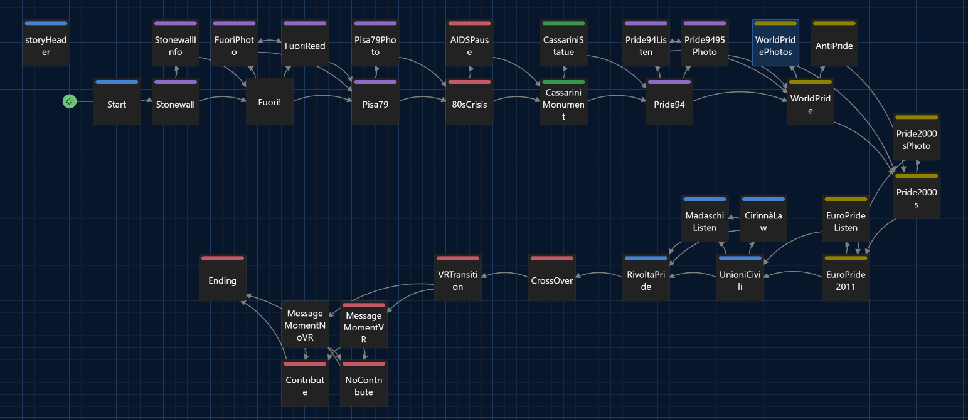
Phase | User action | Touchpoint | Emotion / expectation | Pain point | Design response
Before visit / discovery | Learns about the exhibition via Cassero's social media, word of mouth, or while at the venue for another event; decides to visit. | Social media; posters at the venue; Cassero website | Curiosity; possibly limited knowledge of Italian LGBTQIA+ history. | The Documentation Centre and its heritage are largely unknown, even to regular customers. | The exhibition is physically placed inside the venue’s courtyard intercepting visitors who are already there.
Onboarding | Reads the orientation panel; steps onto the path; the Twine narrative begins | Entrance panel, volunteers. | Openness, slight uncertainty about how the interactive later works | Visitors may not be familiar with interactive narrative formats | The Twine mirrors the physical route one zone at a time; a volunteer is available; choices are simple and low-stakes.
Mission / Goals | Walks the seven chronological zones; reads panels; follows the story from Stonewall to Rivolta Pride. | Physical panels; archival reproductions; Twine passages; era-based visual identity (CSS). | Growing involvement; emotional weight in the 1980s section; energy in the Pride decades. | Some content is emotionally heavy (Giarre, AIDS crisis). | A content note marks the heavier section; the visitor can explicitly choose to take their time or continue.
Capture / interaction | Chooses to stop at testimonies, examine documents, read the Cirinnà law on the totem, open web app deep-dives. | Interactive totem, QR/links to the web app, external video links (Madaschi, Europride, 360°) | Agency, the sense that their path is their own | Multimedia content cannot all be displayed physically. | The web app hosts full multimedia deep-dives; the Twine records each interaction as a narrative variable.
Feedback / scoring | Experiences the VR in the ballroom; writes a personal message in the Twine; reads the personalised ending. | VR headset + 360° recording; Twine input box; message wall; final recap screen. | Immersion and emotional peak (VR); personal connection; sense of having contributed. | Some visitors may be uncomfortable with VR headsets. | A volunteer briefs each visitor; the same 360° video is available on a regular screen and via link as a fallback.
After experience | Continues exploring content on the web app; may return to the venue or the archive's online catalogue. | Web app; centrodocumentazionecassero.it; published Twine (standalone HTML). | Desire to learn more; lasting impression | The physical archive upstairs is not directly accessible to casual visitors. | The web app acts as the permanent digital gateway to the archive’s collections.

Twine link
https://github.com/nixasc/ffp_exhibition/blob/main/fightingforpridetwine.twee

8. Response to Pain Points and Innovation
Pain point identified in Section 1 | Design solution | Expected effect
Even people attending regularly Cassero’s activities aren’t often aware of their archival work | The project displays and promotes part of Cassero’s collection in the space in which also other activities take place, promoting affluence. The exhibition also aims to show the material in an engaging and intriguing way. | People who are already interested in other activities promoted by Cassero will be further informed in their archival work, and will therefore be able to learn about Italian LGBTQIA+ history.
The archive does not have a dedicated space for exhibitions. It does have a court outside, and a hall dedicated to events. | The exhibition will take place in the outside space available to Cassero and in their hall. | The exhibition will be easily reachable to both people already familiar with Cassero and their activity, and also to tourists, who will be able to find it just by browsing the city, given that the hall is quite large and is next to a public park..
A large portion of the material preserved by Cassero is multimedial (registration, videos…). | The exhibition will be largely hybrid, adding videos, registration, music and other elements. Those elements will be available both on personal devices and on dedicated totems all around the exhibition for people not possessing an adequate device. | The exhibition will represent Cassero's work more holistically. It will also be more engaging for the audience, who will have different sorts of inputs and resources to browse.
The archive is so large that it may be hard to browse through the digital content without guidance | The exhibition will have a strong theme key and a strong narration, so that it will be easier for the audience to follow through. It will also be left available online for Cassero archive’s users. | The audience will have grasped some key points of ItalianLGBTQIA+ history, focusing on the importance and history of Pride. It will also be left as a starting point for people to browse the archive digitally.

8.1 Innovation beyond the state of the art
The proposed exhibition introduces an innovative hybrid approach to heritage interpretation by combining a physical exhibition with a permanent digital archive, making Italian LGBTQIA+ history more accessible, engaging, and sustainable. While some exhibitions taken as reference have successfully combined physical displays with digital elements, many of their online resources are no longer available, limiting their long-term impact and accessibility. This project addresses that gap by integrating the exhibition with a searchable digital archive that remains available beyond the exhibition's duration. Rather than presenting archival material as static records, the project transforms them into an interactive experience through multimedia content, including photographs, videos, audio recordings, oral histories, and documentary material, allowing visitors to explore the archive both on-site and remotely, through a 3D model and a complementary WebApp. By increasing the visibility of underutilised archival resources and ensuring continued public access after the exhibition closes, the project creates a more sustainable model for preserving, interpreting, and disseminating Italian LGBTQIA+ heritage while supporting diverse media types and audience targets.

9. Conclusion

Fighting for Pride proposes an immersive hybrid exhibition for the Cassero LGBTQIA+ Center in Bologna, designed to make the history of the Italian Queer movement visible, emotionally accessible and permanently documented. By structuring the visit as a physical march through seven chronological zones, integrating a Twine interactive narrative and a web app for multimedia content, and culminating in a VR experience, the project addresses the four main pain points identified: public unawareness of the archive, lack of dedicated exhibition space, underuse of audiovisual materials, and the difficulty of navigating the archive without guidance.
The project’s main limitation is its dependency on the venue’s layout and on the availability of volunteers for the visitor onboarding.
The project contributes to the broader field of digital heritage by demonstrating how a community archive with limited space and resources can design a rich, layered visitor experience by combining low-cost digital tools for the development (Twine, Figma Make) with a strong physical concept rooted in the specific history of the place.

Acknowledgments and Team Roles
Team member | Role in project design | Role in writing the paper
Nicoletta Ascione | Experience & Interaction Designer, Visual Designer | 1-5, 6
Silvia Lusenti | Experience & Interaction Designer, Prototype Designer | 1-5, 8
Alice Sgarlata | Research, Experience & Interaction Designer, Narrative Designer | 1-5, 7

Acknowledgment text
The team wishes to thank the staff of the Documentation Centre “Flavia Madaschi” and Cassero LGBTQIA+ Center for their availability during the on-site visit, especially Sara De Giovanni (Archive Coordinator), for providing us access to the archive’s catalogue and physical materials, and for their generous collaboration in defining the exhibition’s scope and content.
We also thank professors Tartarini and Pescarin from the Digital Heritage and Multimedia Course at the University of Bologna for the methodological framework suggested and for the great opportunity of creating an interesting project from scratch.

References

Alliva, S. (202). Fuori i nomi! : intervista con la storia italiana Lgbt. Roma: Fandango libri.
Benyon, D. (2014). Designing User Experience. Harlow: Pearson.
Biagini, E. (2018). L’emersione imprevista: il movimento delle lesbiche in Italia negli anni ‘70 e ‘80. Pisa: ETS.
Capogna, G. & Paladini, L. (2020). Over the rainbow: dieci discorsi dal Pride. Gallarate: People.
Grillini, F. (2008). Ecce omo: 25 anni di rivoluzione gentile. Milano: Rizzoli.
Pescarin, S., Massidda, M., Travaglini, L., Spotti, S., & Veggi, M. (2025). PERCEIVE Co-design Tool for Cultural Heritage Experiences. Zenodo. https://doi.org/10.5281/zenodo.15173219

Web Links

- Centro Documentazione Flavia Madaschi. Accessed June 2026. https://cassero.it/centro-documentazione/
- Hope to Nope: Graphics and Politics 2008–18. Accessed June 2026. https://www.graphicdesignand.com/shows/hope-to-nope
- Copy Machine Manifestos: Artists Who Make Zines | Brooklyn Museum. Accessed June 2026. https://www.brooklynmuseum.org/it-IT/exhibitions/copy_machine_manifestos_artists_who_make_zines
- LGBTQ+ VR Museum. Accessed June 2026. https://lgbtqvrmuseum.com/
- Wikipink. Accessed June 2026. www.wikipink.org
- Figma. Accessed June 2026. www.figma.com/
- Draw.io. Accessed June 2026. https://www.drawio.com/
- ACNP - Italian Periodicals Catalogue. Accessed June 2026. https://acnpsearch.unibo.it/custom/bo808
- Politics Posters Catalogue. Accessed June 2026. https://www.manifestipolitici.it/SebinaOpacGramsci/article/cose-manifestipoliticiit/manifestipolitici
- How the Stonewall Riots Sparked a Movement | History. Accessed June 2026. https://www.youtube.com/watch?v=Q9wdMJmuBlA
- Tuttinpiazza – Bologna '95. Accessed June 2026. https://www.youtube.com/watch?v=enEFsK6uY6k
- World Pride ROME 2000. Accessed June 2026. https://www.youtube.com/watch?v=w62zzfg27gE
- Lady Gaga to Europride in Rome (Italy) 2011 – Full. Accessed June 2026. https://www.youtube.com/watch?v=Gu5k550cGfA

Appendix: Design Brief Summary

Our project, Fighting for Pride – The Italian Path to LGBTQIA+ Resistance, is a hybrid exhibition taking place at Cassero LGBTQIA+ Center, and based around the Flavia Madaschi Documentation Center.

Its primary audience are young, international people, and its secondary audience are adults.
Their characteristics are:
- Primary audience: young, international student, already knows about general Pride history but lacking knowledge in Italian Pride history, interested in the topic and eager to learn more about it, skilled in using digital tools.
- Secondary audience: adult visiting the city, less skillful with digital tools, not particularly interested in Pride per se but curious to learn more about specific cultural events.

The context of the project revolves around the documentation Center “Flavia Madaschi” and the project itself is developed through documents selected from the Center, which is also the biggest community archive in Italy and Europe specialized in the preservation of LGBTQIA+ history.
The main pain problems are:
- The public is not aware of the archive's existence, missing crucial information on Italian Pride;
- The archive does not have a dedicated space for exhibitions;
- A large portion of the material preserved by Cassero is multimedial, making them difficult to display in a traditional sense;
- The archive is so large that it may be hard to browse through the digital content without guidance.

Analysing what has been already produced and considering what is already available as a solution, several relevant benchmarks that address similar challenges were identified. These include Hope to Nope: Graphics and Politics 2008-18, which demonstrates the effectiveness of using political posters and visual culture to narrate social movements; Copy Machine: Manifestos: Artists Who Make Zines, which highlights publications as historical sources for marginalized communities; the LGBTQ+ VR Museum, an online immersive museum preserving LGBTQIA+ heritage through virtual reality; and the digital archive of the Centro Documentazione Flavia Madaschi, which provides online access to a rich collection of archival materials. Together, these references demonstrate different approaches to preserving and communicating cultural heritage through physical exhibitions, digital archives, and immersive technologies.

Nevertheless the solutions already available do not solve several key issues. Existing physical exhibitions often disappear once they close, leaving no digital legacy. Digital archives provide extensive documentation but lack an engaging narrative and guided visitor experience. Virtual museums privilege immersive exploration but generally focus on individual stories rather than the historical evolution of collective activism. Lastly, very few projects successfully integrate a permanent physical exhibition, an accompanying digital archive, multimedia storytelling, and immersive technologies into a single coherent visitor experience.

Star Assets of the project are:
- Lady Gaga’s speech at EuroPride 2011, an emotional speech that can draw attention even from uninterested people, transforming them into potential visitors;
- The archival collection from the Flavia Madaschi center that, with more than 20,000 books and 10,000 multimedia files, constitutes the biggest European archive of its kind and is an invaluable cultural resource.

The reference institution is Cassero LGBTQAI+ Center and its institutional goals are to preserve LGBTQAI+ history and culture, and at the same time to specifically publicize the Flavia Madaschi Center to a bigger public, because it is often overlooked and it doesn’t receive the same coverage as the rest of the Center.

The audience goals the project is targeting are:
- Learning about Italian LGBTQIA+ history in an engaging way;
- Discovering the Flavia Madaschi Documentation Centre and the importance of heritage preservation.
The primary target audience would be motivated to experience the project by:
- Discovering the history of Italian Pride, complementing their existing knowledge of international LGBTQIA+ history;
- Visiting an original and interactive cultural experience, combining physical exhibitions with digital media and VR.
It might experience specific barriers like:
- Language barriers, since much documentation is originally available only in Italian;
- Limited awareness of the archive's existence, making it difficult to discover these resources independently.
The audience is nevertheless capable of:
- Using digital technologies;
- Understanding the broader history of LGBTQIA+ rights, providing useful background knowledge;
- Actively exploring multimedia content.
It can use devices such as:
- Smartphones;
- VR headsets.

My secondary target audience would be motivated to experience the project by:
- Learning more about Bologna's cultural heritage while visiting the city.
- Discovering an unfamiliar chapter of Italian civil rights history through an accessible exhibition.
It might experience specific barriers like:
- Limited confidence with digital technologies, especially QR-code interactions and VR.
- Accessibility or mobility issues, due to the partially outdoor exhibition path.
The audience is nevertheless capable of:
- Empathising with personal stories and historical narratives;
- Using basic digital tools, such as smartphones and websites;
- Engaging with cultural exhibitions out of curiosity and personal interest.
It can use devices such as:
- Smartphones;
- VR headsets (with assistance if needed).
The main idea of the project is to recreate the experience of participating in a Pride march by transforming the exhibition into a chronological journey through more than fifty years of Italian LGBTQIA+ activism. Visitors progress through historical stages enriched by archival documents, photographs, videos, audio testimonies and digital content accessible through a companion WebApp. The experience culminates in an immersive VR recording, allowing visitors to emotionally experience it.
To better describe the project, the user journey is described in detail in the Twine file available here.
The interactions include the QR codes, which are provided throughout the exhibition and lead to the WebApp, where extra material is provided. Another form of digital interaction is provided by the VR experience at the end of the exhibition, once the visitor reaches the last hall. Lastly, the visitor can leave a pinned message for everyone to read.
The hybrid elements and technological elements and their role are:
- the WebApp: redirects visitors through QR codes to extra material that can be accessed during or after the visit.
- the VR experience: situated at the end of the path, provides an extra layer to experience firsthand a Pride march.
The project addresses the above-mentioned pain-points by integrating the exhibition with a searchable digital archive that remains available beyond the exhibition's duration. Rather than presenting archival material as static records, the project transforms them into an interactive experience through multimedia content, including photographs, videos, audio recordings, oral histories, and documentary material, allowing visitors to explore the archive both on-site and remotely, through a 3D model and a complementary WebApp.
Its innovation lays in the combination of physical and digital access to the materials, which will be granted even after the exhibition ends.

